Name
Institution
Course
Date
Lobbying Heats Up Over US Ethanol
- By Mario Parker/Bloomberg News Editor. February 9, 2017.
www.renewableenergyworld.com/articles/2017/02/lobbying-heats-up-over-us-ethanol.html

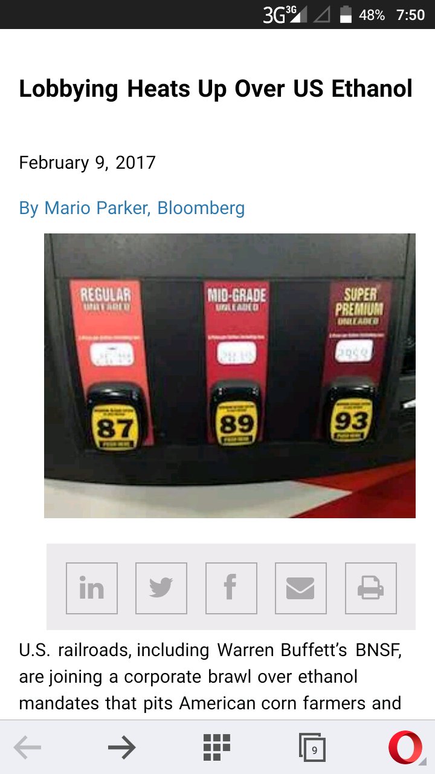
“Lobbying Heats up over US Ethanol” is an article by Mario Parker. It talks more about how the production of ethanol should be increased in the US to allow only consumption of biofuels.
Key Words: Ethanol and Biofuels
Warren Buffets is among the U.S railroads that has decided to join the race to deal with ethanol mandates which has made American corn farmers together with a number of fuel distributors to protest against oil refineries. The renewable fuel standards that works with companies such as Valero Energy Corp has been experiencing a down time due to American association of rail roads (AAR) has developed lack of interestin changing their sources of energy from non-renewable to renewable.
At issue is who’s responsible for showing compliance with the program. Adherence is tracked by paper credits that have become more expensive in recent years. Refiners argue that the costs are exorbitant and that the Environmental Protection Agency, the regulator that has jurisdiction over the mandate, should move the onus from them to lower down the supply chain, closer to consumers.
That would put companies such as BNSF, the carrier owned by Buffett’s Berkshire Hathaway Inc., and Union Pacific, the largest publicly traded U.S. railroad, on the hook for showing compliance with the credits, AAR said in an e-mailed statement Monday. It would also increase fuel prices, the lobbying group said.
Consumer Impact
“American consumers will ultimately absorb the impact,” said Kristin Clarkson, an AAR spokeswoman.
The lobby “is speaking on behalf of BNSF and the other railroads who are members,” Michael Trevino, a BNSF spokesman said in an e-mail.
Susan Terpay, a spokeswoman for Norfolk Southern, also said AAR’s efforts are in support of the railroad industry. Spokesmen for CSX and Union Pacific didn’t return messages left for comment. Icahn, who owns an 82 percent stake in CVR, declined to comment.
“Moving the point of obligation helps small retailers,” Valero said in an e-mailed statement Tuesday. The impact on fuel retailers would be “positive,” by creating a “level playing field” between smaller and larger companies, Valero said.
Petroleum refiners are required to blend renewable fuels like ethanol into U.S. gasoline as part of a 2007 energy law passed under President George W. Bush that sought to slow the pace of oil consumption and its carbon footprint. Each gallon is tracked by a unique, 38-digit Renewable Identification Number (RIN).
If, like Icahn’s CVR Energy, a refiner doesn’t have facilities to add the biofuels, it has the option to purchase them on the open market, often from gasoline distributors that aren’t covered by the mandate, or they can buy excess RINs from refiners that have the infrastructure to blend. CVR Refining, a subsidiary of CVR Energy, estimates it may have spent $250 million on credits last year.
About Mario Parker

Mario Parker is a news editor and a journalist at Bloomberg News. The author majors in various fields such as agriculture, finance, energy and general breaking news. He is a professional with several experiences and expertise in the field of journalism. He attained a master’s degree in journalism in 2006. He also happens to have a bachelor’s degree in communication arts. His skills are vast and within his works, he has been able to portray these skills in writing articles and editing news concerning renewable fuels, energy, investigative reporting and financial reporting. In addition, the author has acquired several awards out of his great works and amongst there are “Society of American Business Editors and Writers” back in May, 2011 and “New King Coal” in November, 2010.

